Task on AGRO CD
- Setup ARGO CD
  - Check cluster
kubectl get nodes
Nodes must be Ready.
  - Install Argo CD
kubectl create namespace argocd
kubectl apply -n argocd --server-side --force-conflicts \
-f https://raw.githubusercontent.com/argoproj/argo-cd/stable/manifests/install.yaml
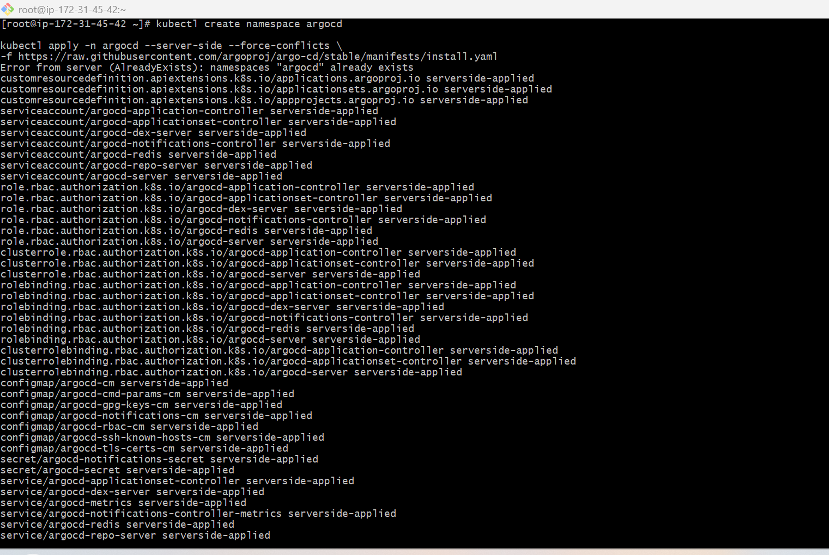
  - Check pods
kubectl get pods -n argocd
Wait until all pods show Running.
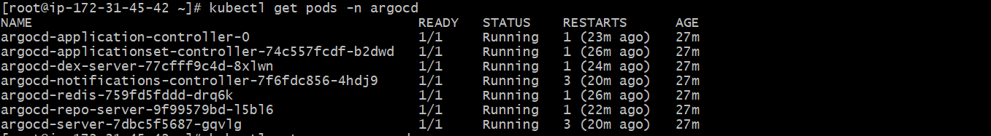
  - kubectl get svc -n argocd
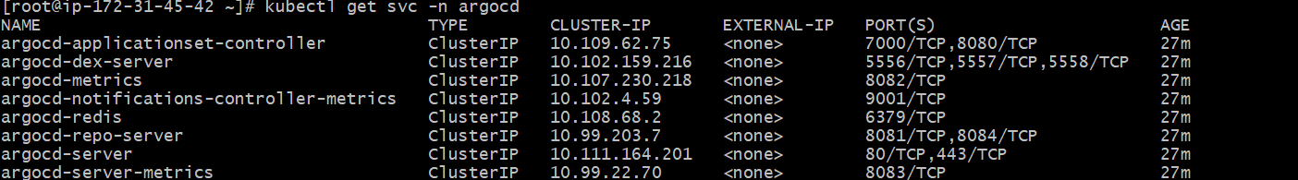
  - Expose Argo CD UI using LoadBalancer
For EKS:
kubectl patch svc argocd-server -n argocd \
-p '{"spec": {"type": "LoadBalancer"}}'
  - Check URL:
kubectl get svc argocd-server -n argocd
Copy the EXTERNAL-IP / DNS name.
Open in browser:
https://<EXTERNAL-IP-or-DNS>
Browser may show security warning. Click Advanced → Proceed.
  - Get Argo CD admin password
kubectl -n argocd get secret argocd-initial-admin-secret \
-o jsonpath="{.data.password}" | base64 -d; echo
Login:
Username: admin
Password: above command output
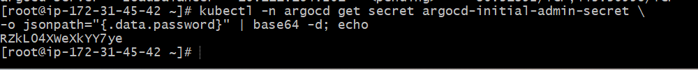
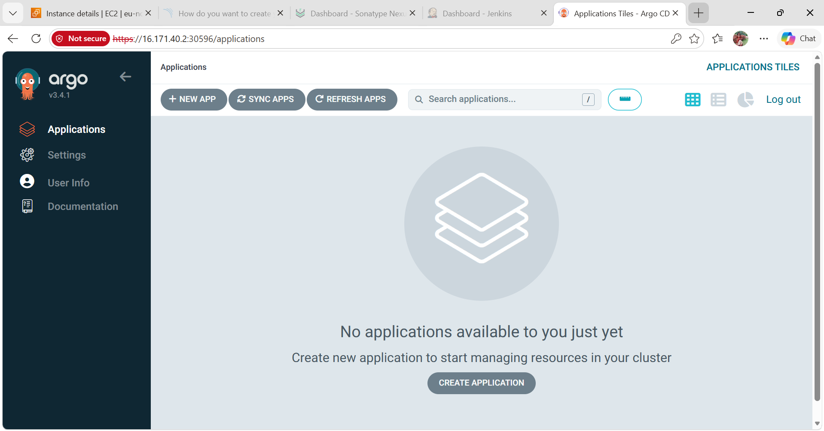
- Create Jenkins job for CI.
pipeline {
agent any
stages {
stage('Git Clone') {
steps {
git branch: 'main',
url: 'https://github.com/betawins/hiring-app.git'
}
}
stage('Maven Build') {
steps {
sh 'mvn clean package'
}
}
stage('Test') {
steps {
sh 'mvn test'
}
}
stage('Archive Artifact') {
steps {
archiveArtifacts artifacts: 'target/*.war', fingerprint: true
}
}
}
}
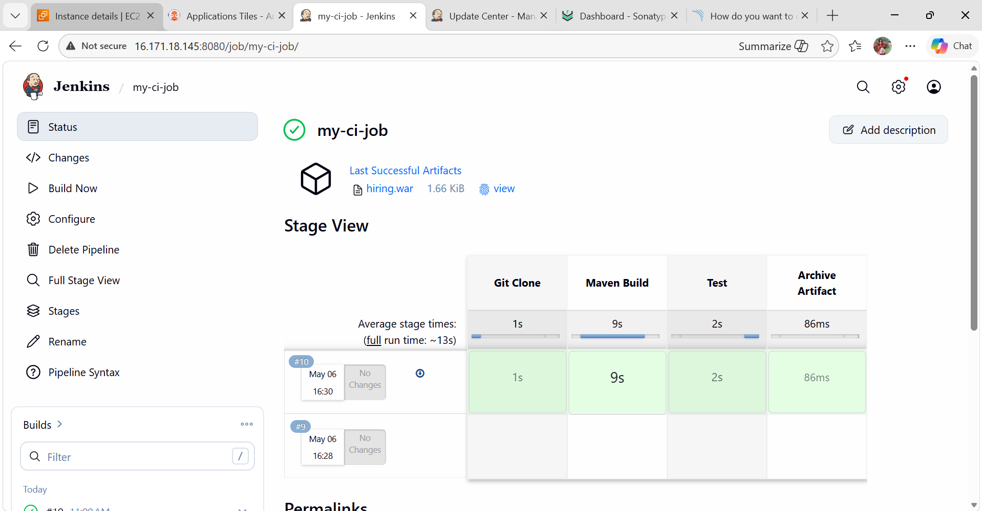
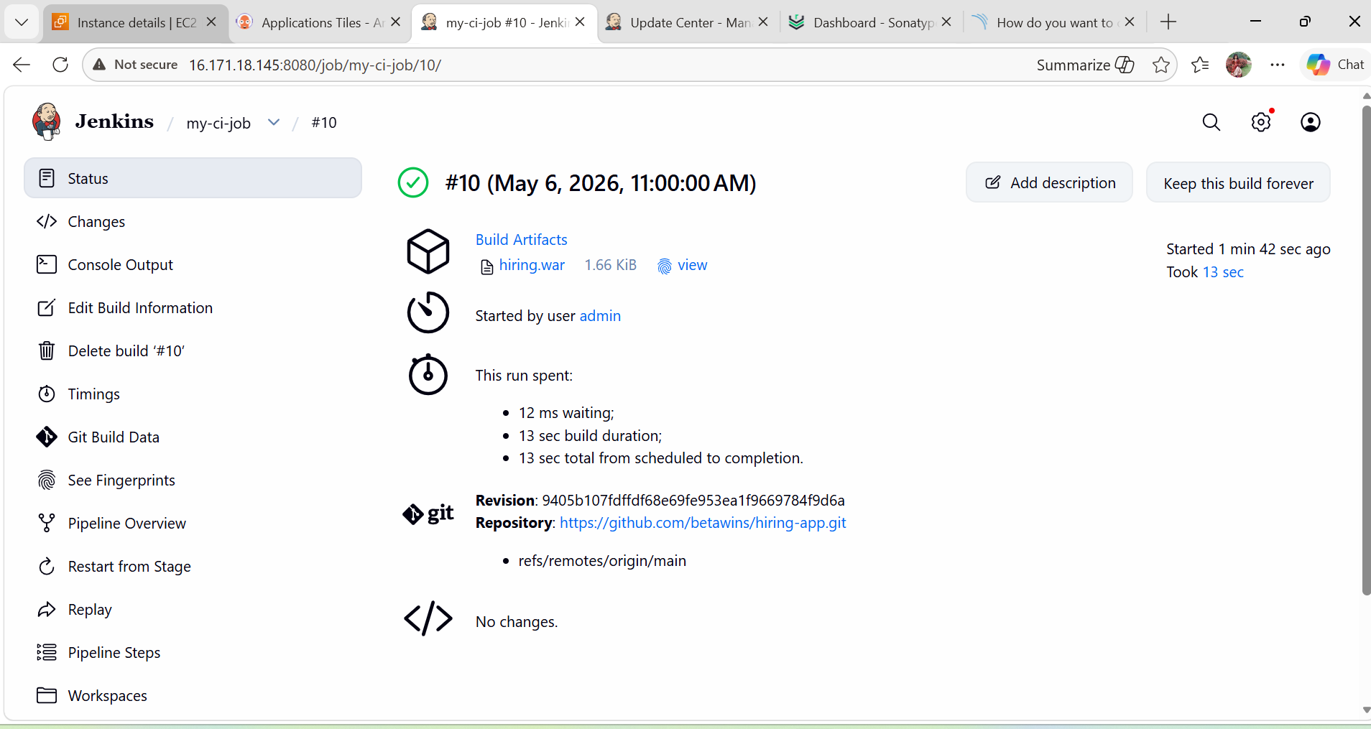
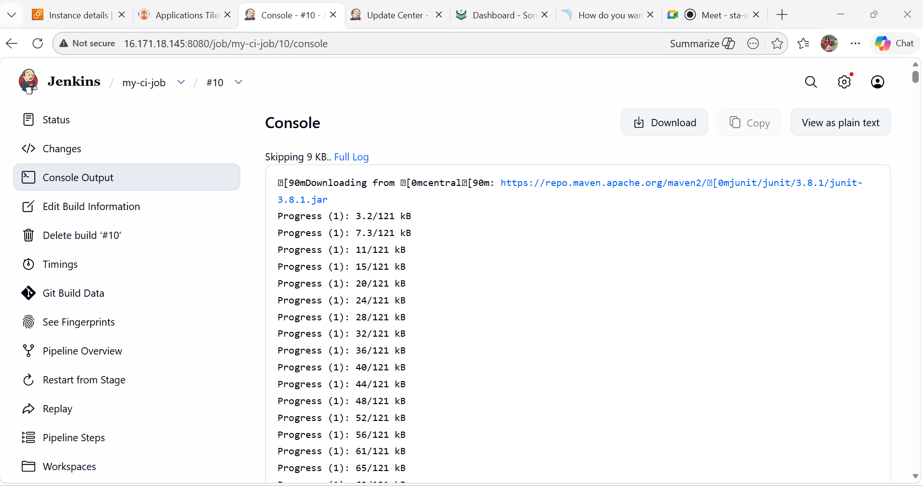
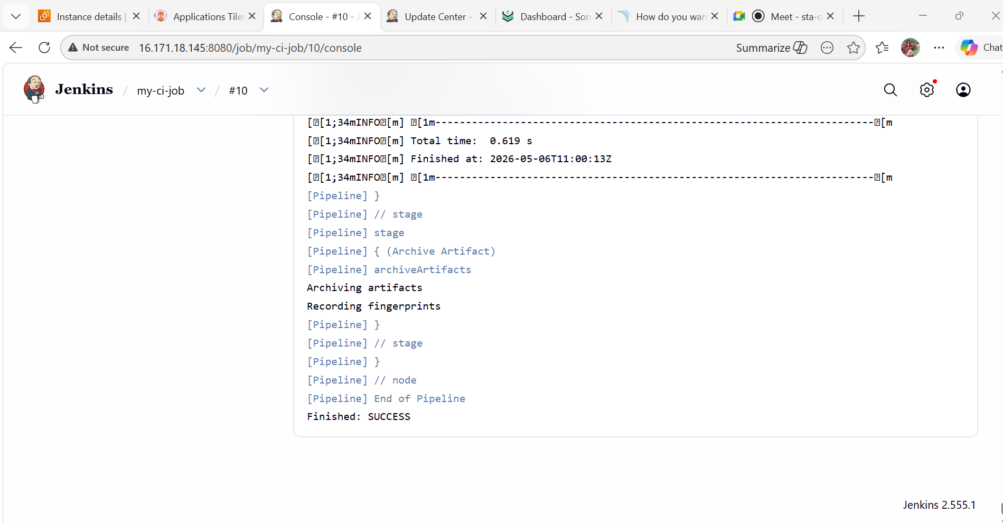
- Create Jenkins job to create docker image and build image.
  - Install Required Tools on Jenkins Server
SSH into Jenkins serve
Install Git
sudo yum install git -y
sudo apt update
sudo apt install git -y
Install Docker
Amazon Linux:
sudo yum install docker -y
Ubuntu:
sudo apt install docker.io -y
Start Docker
sudo systemctl start docker
sudo systemctl enable docker
dd Jenkins User to Docker Group
VERY IMPORTANT.
sudo usermod -aG docker jenkins
Restart Jenkins:
sudo systemctl restart jenkins
OR if Jenkins runs in Docker:
docker restart Jenkins
  - Verify Jenkins Can Access Docker
Switch to Jenkins user:
sudo su - jenkins
Run:
docker ps
If no permission error → perfect.
  - Install Jenkins Plugins
Open Jenkins:
http://<JENKINS-IP>:8080
Go to:
Manage Jenkins
→ Plugins
→ Available Plugins
Install:
- Docker Pipeline
- Git
- Pipeline
- Docker
- GitHub Integration
Restart Jenkins after installation.
  - Add DockerHub Credentials in Jenkins
Go to:
Manage Jenkins
→ Credentials
→ Global
→ Add Credentials
Choose:
Kind: Username with password
Add:
Username: your-dockerhub-username
Password: dockerhub-password
ID: dockerhub-creds
Save.
  - Create Jenkins Pipeline Job
Go to:
New Item
Enter:
docker-build-job
Select:
Pipeline
Click OK.
  - Configure GitHub Repo
Under:
Pipeline
Choose:
Pipeline script
Paste this Jenkinsfile.
  - Jenkins Pipeline Script
For Maven Java Application
pipeline {
agent any
environment {
DOCKER_IMAGE = "naseroddinbaba/myapp"
DOCKER_TAG = "${BUILD_NUMBER}"
}
stages {
stage('Clone Code') {
steps {
git branch: 'main',
url: 'https://github.com/babanaseroddin/jenkins-shared-library.git'
}
}
stage('Build Docker Image') {
steps {
sh 'docker build -t $DOCKER_IMAGE:$DOCKER_TAG .'
}
}
stage('Login to DockerHub') {
steps {
withCredentials([usernamePassword(
credentialsId: 'dockerhub-creds',
usernameVariable: 'DOCKER_USER',
passwordVariable: 'DOCKER_PASS'
)]) {
sh 'echo $DOCKER_PASS | docker login -u $DOCKER_USER --password-stdin'
}
}
}
stage('Push Docker Image') {
steps {
sh 'docker push $DOCKER_IMAGE:$DOCKER_TAG'
}
}
}
  - Add Dockerfile in GitHub Repo
Inside project root:
Example Dockerfile
FROM openjdk:17
COPY target/*.jar app.jar
EXPOSE 8080
ENTRYPOINT ["java","-jar","/app.jar"]
Now push:
git status
git add Dockerfile index.html
git commit -m "Add Dockerfile for Jenkins docker build"
git push origin main
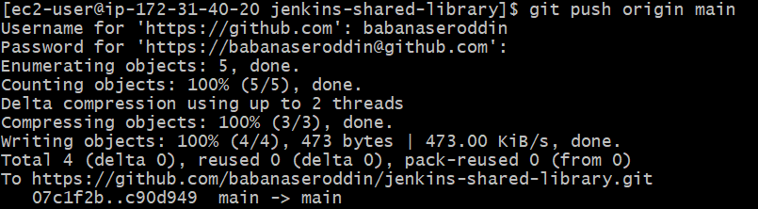
Verify:
git log --oneline -3
ls -la
You must see:
Dockerfile
index.html
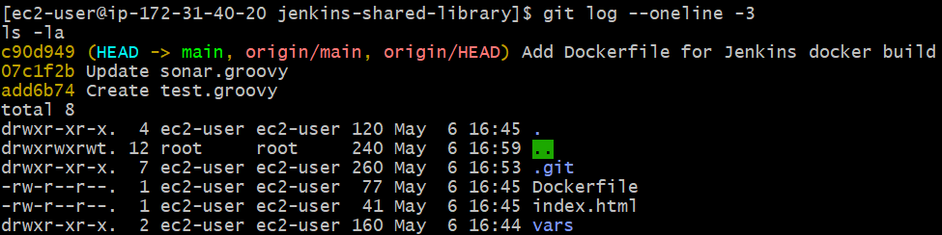

Then run Jenkins job again:
docker-build-job → Build Now

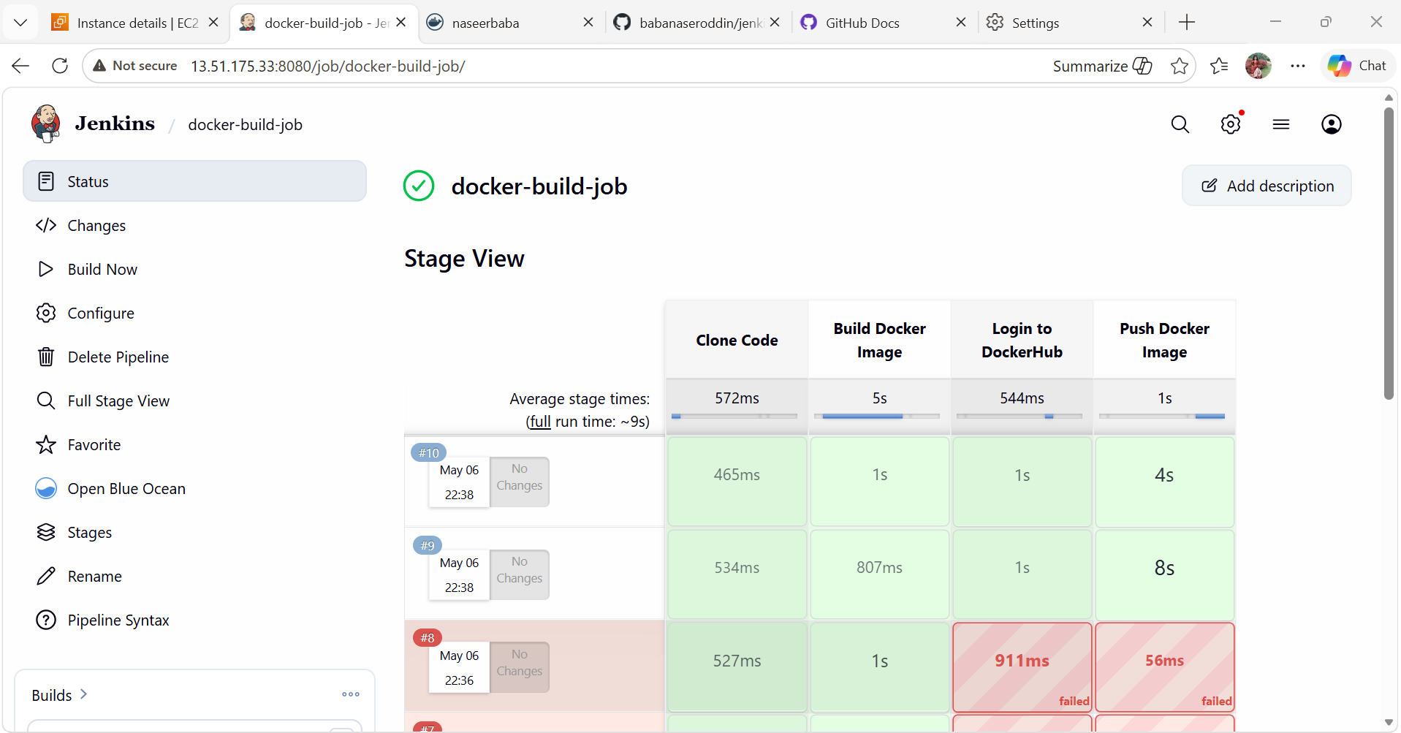

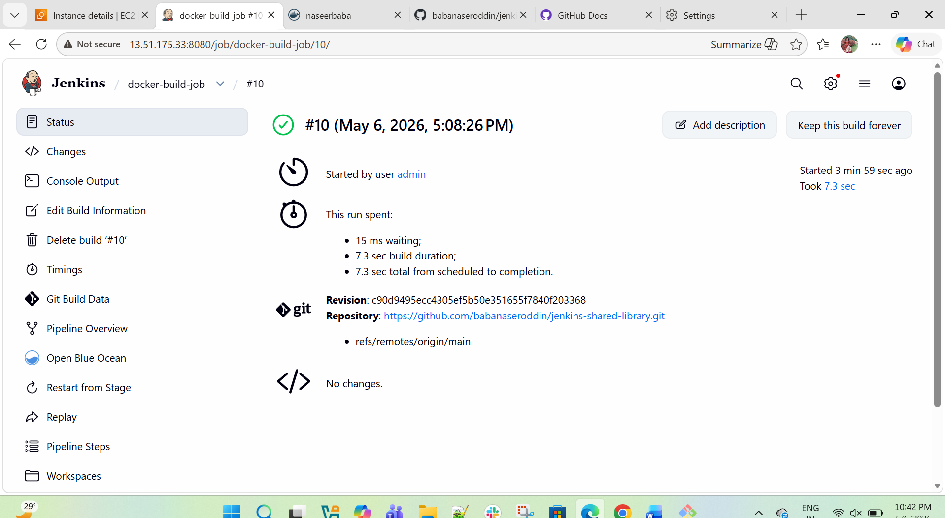
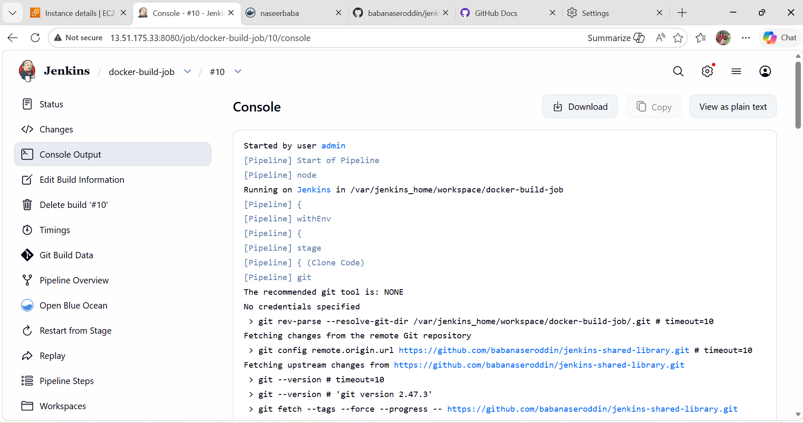

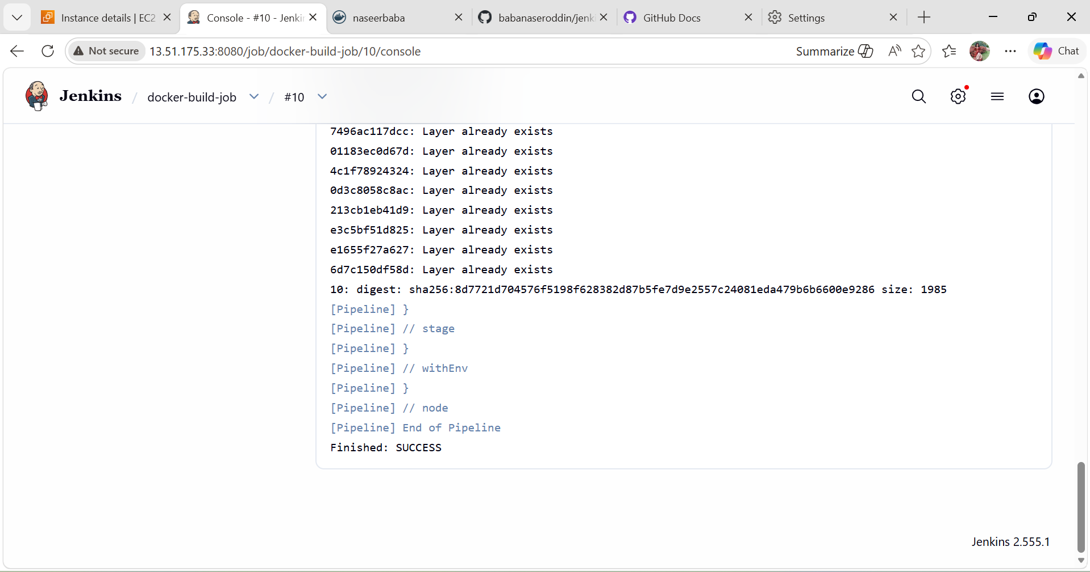
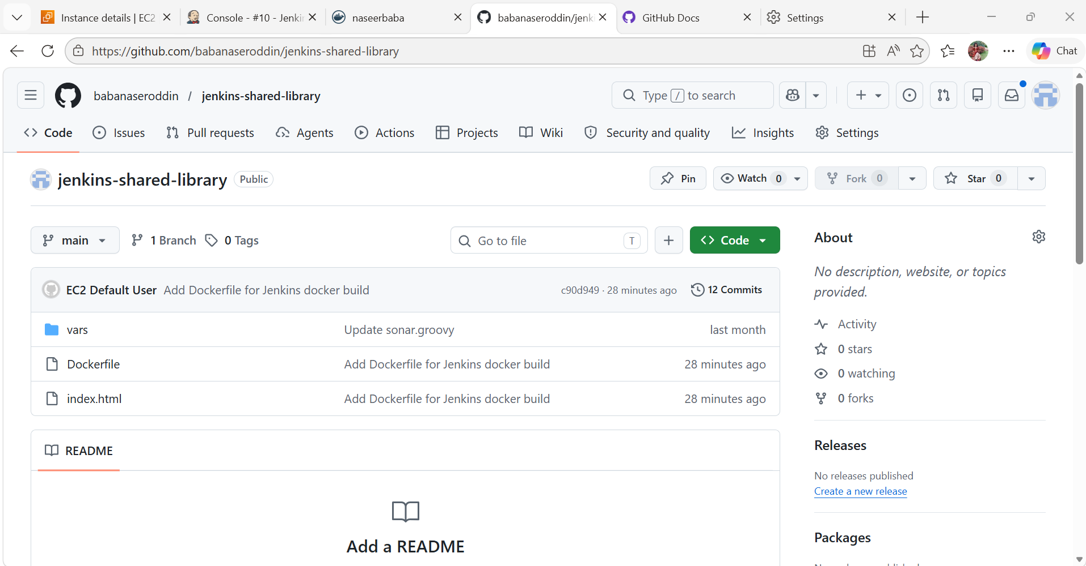

- Create ArgoCD job to deploy on ek8s cluster.
  - Verify EKS Connection
Run:
kubectl get nodes
Expected:
NAME STATUS ROLES AGE
ip-10-0-0-12 Ready <none>
If error comes:
Unable to locate credentials
Configure AWS CLI first.
  - Configure AWS Credentials
Run:
aws configure
Enter:
AWS Access Key ID
AWS Secret Access Key
Region = eu-north-1
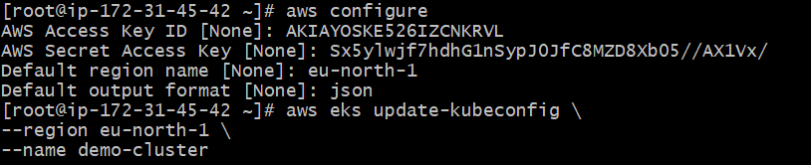
  - Connect kubectl to EKS
Run:
aws eks update-kubeconfig \
--region eu-north-1 \
--name demo-cluster
Test:
kubectl get nodes
  - Install ArgoCD
Create namespace:
kubectl create namespace argocd
Install ArgoCD:
kubectl apply -n argocd \
-f https://raw.githubusercontent.com/argoproj/argo-cd/stable/manifests/install.yaml
Verify pods:
kubectl get pods -n argocd
Wait until all become:
Running
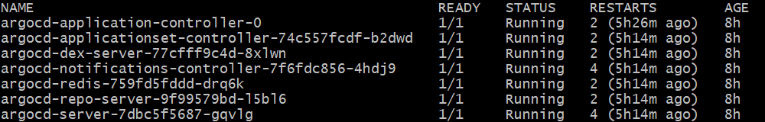

  - Expose ArgoCD UI
Change service type:
kubectl patch svc argocd-server -n argocd \
-p '{"spec": {"type": "LoadBalancer"}}'
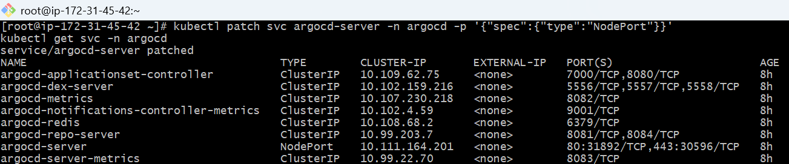
Check external IP:
kubectl get svc -n argocd
You’ll get:
argocd-server LoadBalancer EXTERNAL-IP
Open in browser:
https://<EXTERNAL-IP>
  - Get ArgoCD Admin Password
Run:
kubectl -n argocd get secret argocd-initial-admin-secret \
-o jsonpath="{.data.password}" | base64 -d
Username:
admin
Password:
(output from above command)
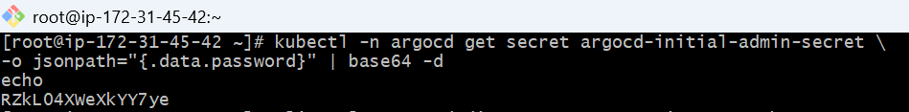

  - Create Kubernetes Manifests Repo
Example GitHub repo structure:
k8s-manifests/
│
├── deployment.yaml
├── service.yaml
  - Create deployment.yaml
Example:
apiVersion: apps/v1
kind: Deployment
metadata:
name: myapp
spec:
replicas: 2
selector:
matchLabels:
app: myapp
template:
metadata:
labels:
app: myapp
spec:
containers:
- name: myapp
image: yourdockerhubusername/myapp:1
ports:
- containerPort: 8080
  - Create service.yaml
apiVersion: v1
kind: Service
metadata:
name: myapp-service
spec:
type: LoadBalancer
selector:
app: myapp
ports:
- port: 80
targetPort: 8080
Push these files to GitHub.
  - Create ArgoCD Application
Open ArgoCD UI.
Click:
NEW APP
Fill:
eneral
Application Name:
myapp
Project:
default
Sync Policy:
Automatic
Source
Repository URL:
https://github.com/yourusername/k8s-manifests.git
Revision:
HEAD
Path:
.
Destination
Cluster URL:
https://kubernetes.default.svc
Namespace:
default
Click:
Create
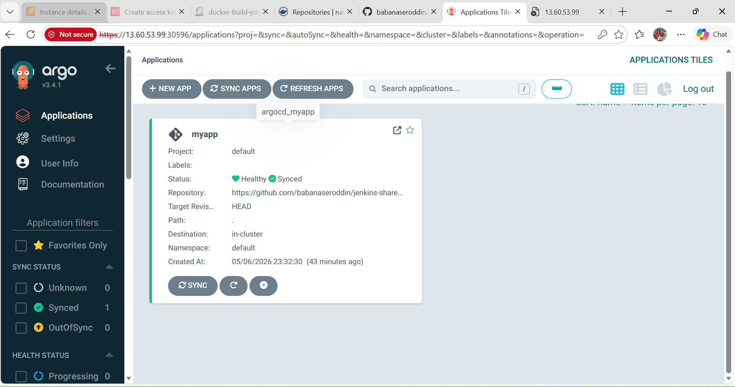
  - ArgoCD Deploys Automatically
ArgoCD will:
✅ Pull manifests from GitHub
✅ Create deployment
✅ Create service
✅ Deploy pods to EKS
  - Verify Deployment
Run:
kubectl get pods
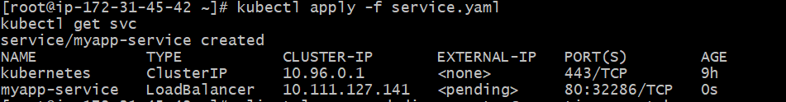
Run:
kubectl get svc
